EXP- 2
Bus Ticket Booking Prototype (Figma)
Aim:
To design a simple Bus Ticket Booking System prototype using Figma.
Procedure:
1. Open Figma and create a new design file.
2. Design screens:
• Home Page
• Search Bus
• Seat Selection
• Payment Page
3. Add navigation links.
4. Present prototype mode.
Screenshots:
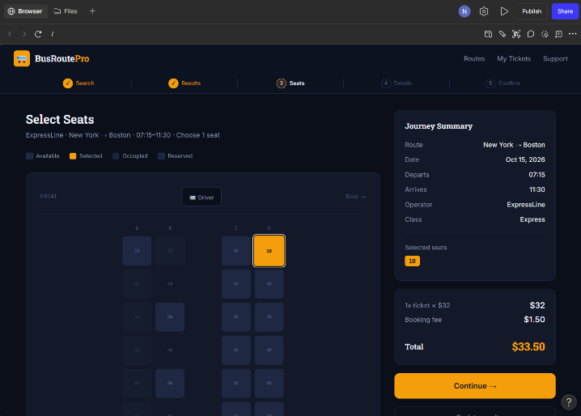
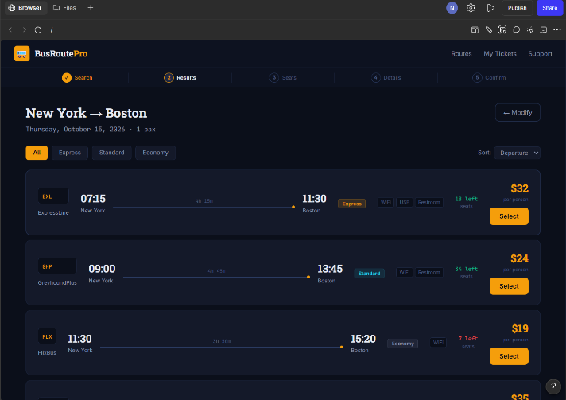

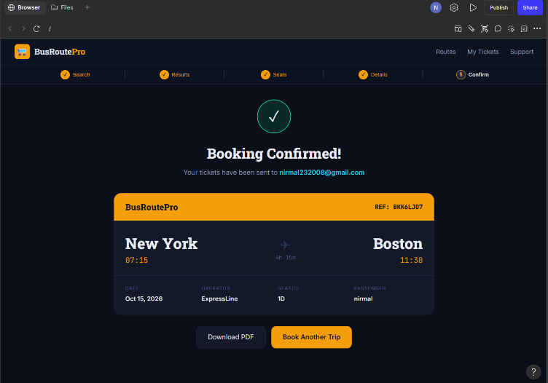
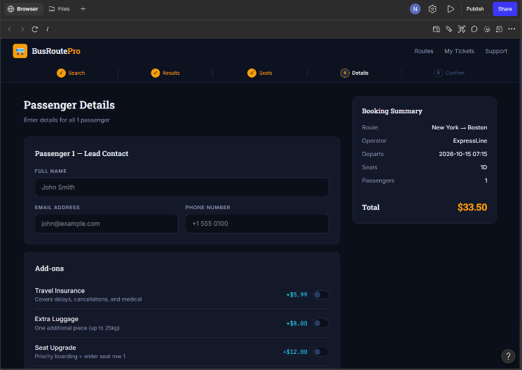

Result: Thus, The clickable prototype of Bus Ticket Booking System was created successfully.

